Synopsis
Project Title : Online Purchase Behaviour Classification

Team id: AI|PH|-T020
Problem Id: 21
Student Name: Ayush Semwal, Shishir Dwivedi, Suryansh Rawat
University Roll number: 2519336, 2519614, 2519543
Section: X

• Problem Description:
In the rapidly growing field of e-commerce, understanding customer purchase behavior is essential for improving sales and user experience. Businesses need to identify whether a user is likely to make a purchase based on their browsing activity, such as time spent on the website, number of clicks, and product views. However, due to the large volume and complexity of user data, it becomes difficult to manually analyze and predict customer decisions.
This project aims to solve this problem by developing a machine learning classification system that predicts whether a customer will purchase a product or not, further more it will compare similar products that the customer is looking for and categories it according to different factors such as(cost, quality, number of people that has bought it, reviews of the product, etc), and make suggestions of products and items to the user. By analysing historical browsing behaviour data, the system can assist businesses in making data-driven decisions, improving targeted marketing strategies, and enhancing customer engagement. This leads to increased conversion rates and better personalization in online shopping platforms.
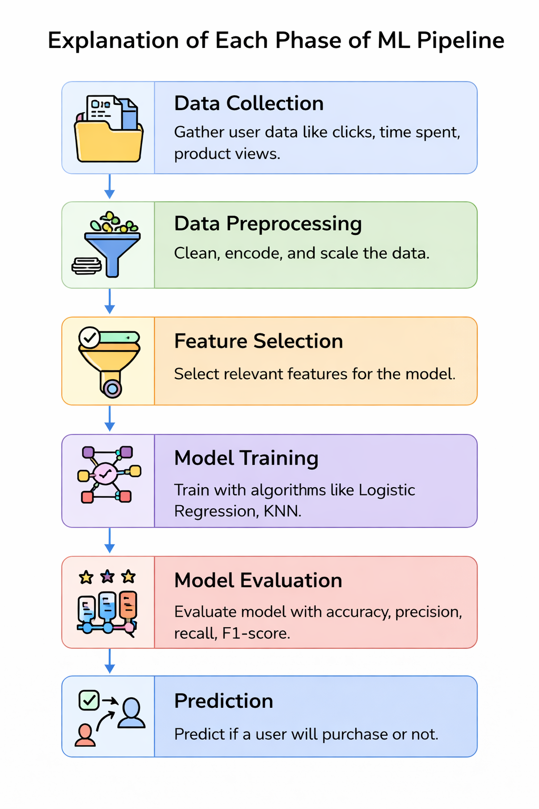
• Explanation of Each Phase of ML Pipeline:

1. Data Collection (User Data)
This is the initial stage where raw data is collected from sources such as e-commerce websites or datasets (CSV files).
The data includes user behavior like browsing time, number of clicks, product views, and pages visited. This raw data is usually unstructured and needs processing.

2. Data Preprocessing
In this phase, the collected data is cleaned and prepared for analysis.
Steps include:
- Handling missing values
- Removing noise and inconsistencies
- Encoding categorical variables into numerical form
- Scaling features using techniques like normalization or standardization
This step is important because machine learning models perform better on clean and structured data.

3. Feature Selection
Not all features in the dataset are useful. In this phase:
- Irrelevant or duplicate features are removed
- Only important features that impact prediction are selected
This reduces model complexity, improves accuracy, and speeds up training.

4. Model Training
In this phase, machine learning algorithms are applied to the processed data.
For this project:
- Logistic Regression is used for binary classification
- K-Nearest Neighbors (KNN) is used to classify based on similarity
The model learns patterns from training data to make predictions.

5. Model Evaluation
After training, the model is tested using unseen data to check its performance.
Evaluation metrics used:
- Accuracy
- Precision
- Recall
- F1-score
This phase ensures the model is reliable and not overfitting.

6. Prediction (Output)
In the final stage, the trained model is used to predict whether a user will make a purchase or not based on new input data.
The output is typically:
- Yes (Purchase)
- No (No Purchase)

Expected Modules / Libraries to be used:
- Numpy:
Used for numerical computations and handling multi-dimensional arrays efficiently.
- Pandas:
Used for data manipulation, cleaning, and handling datasets in tabular (DataFrame) format.
- Matplotlib / Seaborn:
Essential for generating visual plots like ROC curves and correlation matrices.
- Scikit-learn (sklearn):
Provides machine learning algorithms such as Logistic Regression and KNN, along with tools for model evaluation.
- StandardScaler (from sklearn.preprocessing):
Used to scale features so that all variables contribute equally to the model.
- train_test_split (from sklearn.model_selection):
Used to divide the dataset into training and testing sets.
- LogisticRegression (from sklearn.linear_model):
Used for binary classification to predict purchase behavior.
- KNeighborsClassifier (from sklearn.neighbors):
Used to classify data points based on similarity with nearest neighbors.
- Metrics (from sklearn.metrics):
Provides evaluation functions like accuracy, precision, recall, and F1-score.

Expected Evaluation Metrics and Plots to be used:
Evaluation Metrics:
- Precision & Recall:
To measure the accuracy of positive predictions and the model's ability to find all actual defaulters.
- F1-Score:
It is the harmonic mean of precision and recall. This metric provides a balanced evaluation when both false positives and false negatives are important.

Visualization Plots:
- Confusion Matrix:
A table used to visualize correct and incorrect predictions (True Positive, False Positive, etc.), helping to understand model performance in detail.
- ROC Curve (Receiver Operating Characteristic):
Shows the trade-off between true positive rate and false positive rate, helping evaluate classification performance.
- Bar Graphs:
Used to compare the performance of different models (Logistic Regression vs KNN).

- Required Topics from the Subject
Functions: Functions are used to divide the program into smaller reusable modules like data preprocessing, model training, and evaluation, improving code readability and efficiency.
Libraries:Libraries such as NumPy, Pandas, and Scikit-learn are used to perform data analysis, preprocessing, and implementation of machine learning algorithms efficiently.
Supervised Learning: Understanding the fundamentals of classification where models learn patterns from labeled training data.
Feature Engineering: Knowledge of transforming raw data into features that better represent the underlying problem to the model.

- Platform Required:
Jupyter Notebook / Visual Studio Code / Python IDLE

